Guidelines for applications:

Eligibility
Tony Elischer foundation supports individuals who have already demonstrated they have a talent for fundraising in their first roles as a fundraiser and have drive and ambition to become the next generation of leaders. There are no geographical restrictions and support is provided without any fees for the programme participants.
Applicants must be committed to developing a career in fundraising.

Selection Process
Applications can be made at any time, with three cut off dates each year (dates are advertised on our website) after which the submissions will be reviewed by the Director and Trustee Board.
Applications will not be considered unless they are accompanied by a nominator form and short video as detailed in the application process. All must arrive by the deadline.
There are not a fixed number of places and we will assess individuals based upon their online form and video submission. The quality of the applications will determine the success of the applicant but we will aim to support a diverse group of individuals from a range of organisations, locations, gender and race.
Applicants will hear if they have been successfully shortlisted within four weeks of the closing date. A further interview (face to face or via skype) will be undertaken in order to determine the final successful individuals.
All applicants will be informed if they have been successful or not within four weeks of the closing date.

Nominator Forms and Referees
All applications must include a nomination from another person who can recommend why you would be an ideal candidate to benefit from our support. Applications will only be considered if a nomination is also received so please ensure you get them to send the form in time to meet the deadline.
Your nominator must know you well and be able to explain why you have the potential to become a future leader in fundraising, so think about who is best placed to do that for you. They do not need to be someone with an impressive CV – it is not about their credentials but about knowing you and being able to recommend you.
We do also ask for a referee when you reach the shortlisted stage. This must be your fundraising employer. We will only contact them after checking with you.

Notes for nominators
We appreciate you supporting an individual in their application to benefit from our programme of support at Tony Elischer Foundation. We need to understand why they are suitable and how you think they would benefit and ask you to complete a short nomination form. This is just to provide your contact details and asks you to write a short recommendation summarising the qualities which the individual has that suggest they will benefit from our support.
We will only use your details to contact you about the details on the form. However if you would like to learn more about our work and how you can get involved, please indicate this on the box or email to info@tonyelischerfoundation.org

What we are looking for in your application
The application is designed to help us get to know you and understand your passion for fundraising so answer the questions in a way which is honest and conveys your beliefs, approach to your work, personality and achievements.
After reading your form and watching your film, we want to have a sense that we know you and understand what drives you to achieve success in your work. We are hoping to see energy, creativeness and individuals who are not afraid to innovate and challenge how things are done; improving them for a better future.
Don’t be afraid to say what it is you want to learn and how you want to develop. Our way of working is very adaptable and individual to your needs so much better that you are self aware and can articulate how you hope you can improve your approach and skills.

Video application
The topic which you need to address is
“Why I am a fundraiser”
The film should be a maximum of 2 minutes long and does not need any special effects or fancy editing. Let us see a snapshot of who you are.
It is entirely up to you what approach you take but the film must be uploaded as a private video on Youtube ( see guide below) with the link to this entered into the application form.
Guide to uploading a private video to YouTube

- Sign into your YouTube account.
- Click on Upload at the top of the page and select your video from your computer
- As the video uploads, change the video privacy settings to ‘Private’ here:
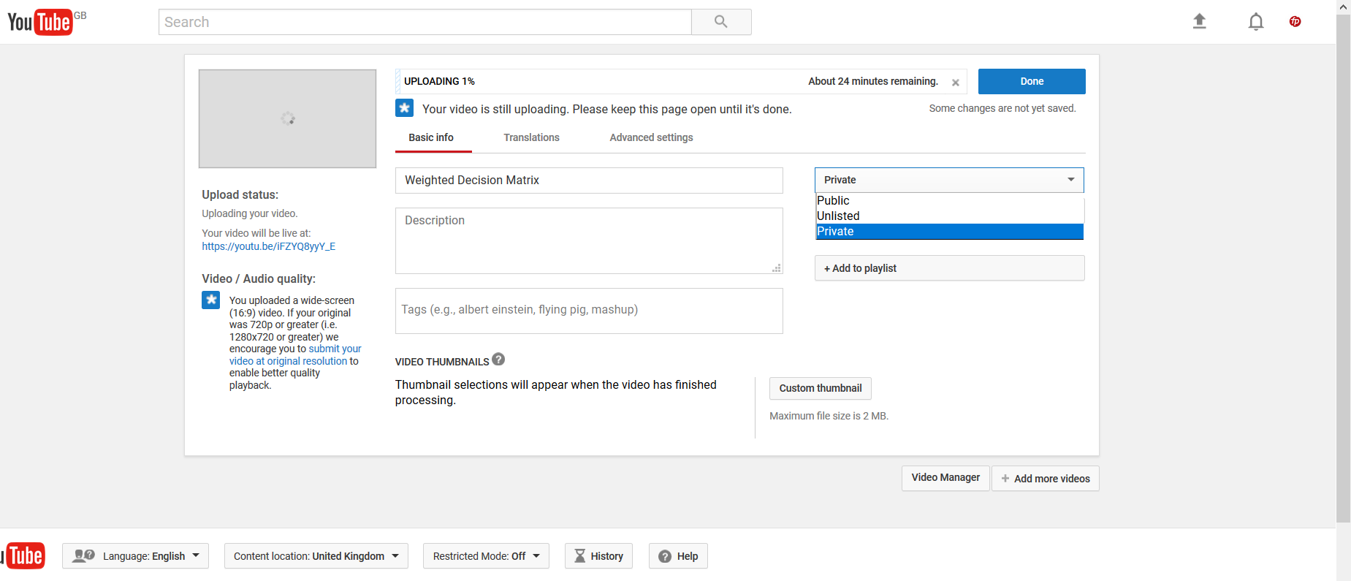
- As the video is uploading you can edit both the basic information and the advanced settings of the video. You should untick the ‘notify subscribers’ and ‘Allow Embedding’ in the Advanced Options tab
- Copy and paste the URL of your video into the application form on the TEF website. The video URL can be found here:
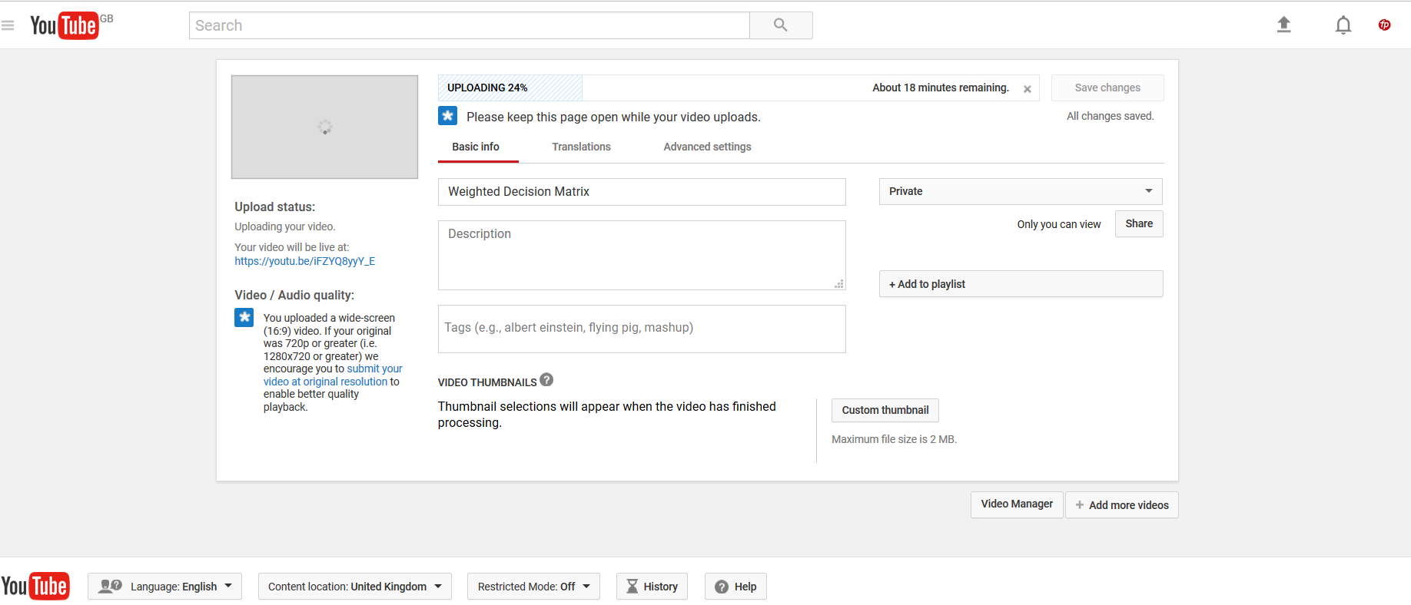
- You will also need to share the video with us in order for us to be able to see it. On the Basic Info tab, click the Share button, enter “sue@tonyelischerfoundation.com” and “info@ tonyelischerfoundation.com” and click Ok:
If we have trouble accessing your video we will let you know.

